February 25, 2015
Re: Annual Kathleen Godwin Cole Award
Dear Friend of the Council:
Do you know a volunteer whose leadership and service deserves regional recognition? The Kathleen Godwin Cole Award was established in 1990 in memory of Kathleen Godwin Cole who served for several years on the Council’s Advisory Council on Aging and was Chairman of its Contractor Relations Committee. She was also Chairman of the Buncombe County Domiciliary Home Community Advisory Committee for several years.
This award is given annually to one Land of Sky Regional Council volunteer, aged 55 or better, who has made a major contribution to our region. Nominees need to be from or serve a Region B County - Buncombe, Henderson, Madison or Transylvania.
Below you will find a nomination form for you to complete and send back to us. The deadline for nominations is Friday, March 27, 2015. The award will be presented at the Land of Sky Regional Council board meeting on Wednesday, April 22, 2015. Members of the board include Regional, City and County leaders and officials. All that are nominated will be invited and recognized at the ceremony!
Mail all nomination forms to:

Kathleen Godwin Cole Award
Attn: LeeAnne Tucker
Land of Sky Regional Council
339 New Leicester Hwy., Suite 140
Asheville, NC 28806

Please contact me if you have any further questions. Thank you in advance.
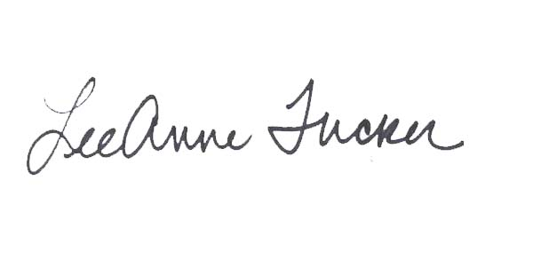
Sincerely,

LeeAnne Tucker
Director of Aging and Volunteer Services

2015
Nomination form for the Kathleen Godwin Cole Award

Instructions:
- Save this document to your computer. 2. Type information into shaded areas.
- Once completed save again. 4. Email or mail the completed nomination form to leeanne@landofsky.org.

Criteria: Must be a volunteer through Land of Sky Regional Council; 55 years of age or better; reside in and perform volunteer service in Buncombe, Henderson, Madison, or Transylvania County; and has made a major contributions and/or impact to Western North Carolina.

Nominee Contact Information
Name of Nominee (older adult volunteer):
Address:
Phone Number (s):
Email:
- Describe major area(s) of volunteer contributions:
- Describe importance of impact of the above to the Region (Buncombe, Henderson, Madison and Transylvania Counties):
- List of leadership/responsibilities for the nominee which relates to the accomplishments: h
- Describe traits of leadership which were instrumental in his/her accomplishments:
- Describe obstacles (if any) which nominee faced in this accomplishment and how these were overcome:
Other Comments:
Note: You may enclose no more than two newspaper articles, supportive letters, or other documentation to support the nominee’s credentials for this award.

Mail, Fax or Email Nomination Forms by Friday, March 27, 2015
Email: leeanne@landofsky.org
Fax: 828-251-6353

Mail:
Kathleen Godwin Cole Award
Attn: LeeAnne Tucker
Land of Sky Regional Council
339 New Leicester Hwy., Suite 140
Asheville, NC 28806

Name of person making nomination:
Name:
Signature:
Address:
Phone Number:
Email:

